CLP Launches Community Development Plan for 8 Local Governments in Ekiti State

In Nigeria, a significant challenge we face is the failure of Local and State governments to conduct thorough needs assessments to identify the priority needs of communities for inclusion in their budgets. Instead, government representatives often allocate projects, such as empowerment initiatives, without clear accountability or community participation but based on demands of political loyalists, thereby primarily benefitting their party supporters. Additionally, they tend to execute projects that do not match the real needs of communities, such as citing a borehole in a community that already has reliable water sources but needs its health centre equipped with ultrasound machines, maternity beds, stethoscopes, weighing scales for newborns, and so on.

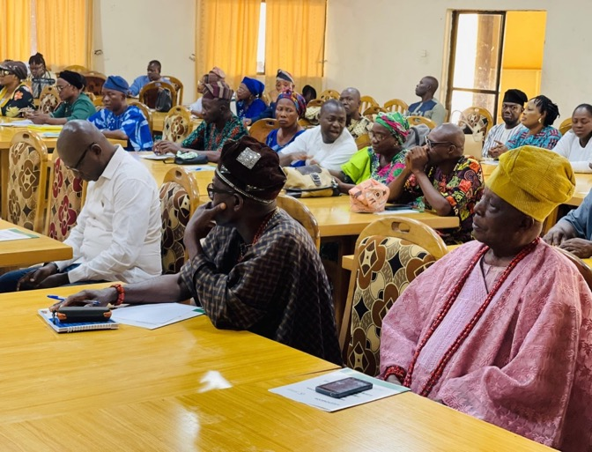
In a bid to solve this problem of wasting funds on projects that are not useful for the community, Community Life Project (CLP), in partnership with the Nigeria Civil Society Situation Room, trained Grassroots Community Leaders and Local Government Officers (Directors of Budget and Community Development) in December 2023 on inclusive budgeting and how to carry out participatory needs assessment. The trained leaders and officials went around the communities and carried out Focus Group Discussions and In-Depth Interviews with different stakeholders to collate the pressing needs of the communities in eight local government Areas of Ekiti State. The stakeholders that helped to identify the needs of the community include chiefs, youths, women, Persons with Disabilities, the elderly and retirees, artisans, workers, health workers, teachers, and traditional rulers. The collated data was used to produce a 3-year Community Development Plan for each of the eight target Local Governments – Ayekire, Efon, Ekiti South West, Emure, Ido-Osi, Ijero, Ikole, and Moba.
Picture of the participants at Launch of Community Development Plans of 8 Local Governments (LG) in Ekiti State organised by Community Life Project in Partnership with Nigeria Civil Society Situation Room
The Community Development Plans were launched on Tuesday, February 27, 2024, by the Honorable Commissioner, Ministry of Local Government Affairs, Chief Folorunsho Olabode. The attendees of this public launch of the Community Development Plans include LG Chairmen, Directors of State Ministries, Departments and Agencies, Heads of Local Government Administration, Directors of Budget and Community Development of the target Local Governments, distinguished Traditional Leaders, and Community Leaders.

The programme Manager of CLP, Francis Onahor, gave an opening remark while a representative of the Permanent Secretary, Ministry of Rural and Community Development, Mrs. Oluwatoyin Ademiluyi, delivered the welcome address. State Ministries, Departments and Agencies (MDAs), Chairpersons, and Heads of all the eight target Local Governments, received copies of the plans at the Launch to serve as a resource for budget planning and resource allocation. Similarly, the Traditional Rulers, Community Leaders, and other stakeholders on the demand side of governance got their copies to serve as a tool for advocating and demanding projects and services from the government and for holding public officers accountable.

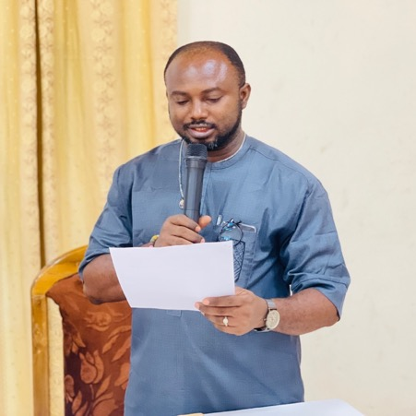
In his opening remarks, at the launch of the Community Development Plans, Francis Onahor, the Programme Manager of Community Life Project (CLP), said the initiative is part of CLP's mission to promote inclusion and grassroots participation in local governance through participatory budgeting. He noted that the unique thing about these plans is that Grassroots Community Leaders and Local Government Officials worked jointly to carry out the needs assessment and collate the data used in producing the plans.
He added that the Plans detail community needs in 6 sectors – Water and Sanitation, Education, Health, Road Infrastructure, Local Economy, and Security; stating that Persons with Disabilities (PWDs) took an active part in the validation of the data from the needs assessment and the specific needs of Persons with Disabilities were also included in the Plans.
Francis Onahor, the Programme Manager of Community Life Project is delivering his opening remarks

While speaking on the benefits of the plans, he stated that the plans will help the government [both State and Local Governments] to know and understand the priority needs of different communities, and wisely allocate resources to meet these competing needs; that it provides reliable data for State Agencies and Local Governments to prepare their yearly budgets and also serve as a great resource for communities to use in engaging their representatives at the State and National Assemblies on the choice of Constituency Projects.

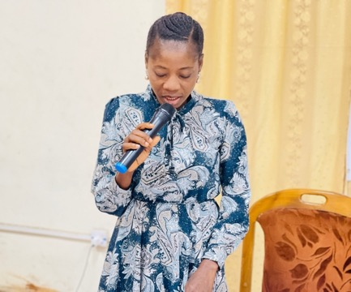
Mrs. Oluwatoyin Ademiluyi, the Director of Administration and Supply, while delivering a welcome address on behalf of the Permanent Secretary of the Ministry of Rural and Community Development, expressed her gratitude to Community Life Project (CLP) for always being there for the ministry since their collaboration began in 2010 and testified that the Plans produced for 8 Local Governments in the past have been of immense benefit to those 8 Local Governments, especially in their budget-making process. She further noted that the Plans have also been very useful to their Ministry in choosing projects for direct intervention by the State Government.
“For almost 14 years now, CLP has been building capacity within the government and at the grassroots community level. They have trained hundreds of Community Leaders and Local Government Officials on participatory budgeting and inclusive governance and supported a series of Budget Town Hall meetings that allowed communities to prioritize their needs for Inclusion in local government budgets. At some point, they provided computer sets to the Community Development Department of all 16 local governments in Ekiti State. In 2017, we Jointly carried out a pilot project in Ikole local Government that led to the production of a 3-year Ikole Local Government Development Plan; and 3 years later, the Ikole Plan was scaled to 8 LGs,” she said.
Mrs Oluwatoyin Ademiluyi, the Director of Administration and Supply, delivering a welcoming address on behalf of the Permanent Secretary, Ministry of Rural and Community Development

Chief Folorunsho Olabode, Commissioner, Ministry of Local Government Affairs, while giving his remark to launch the 3-Year Community Development Plans, stated that the Community Development Plans will help the local governments to improve service delivery and infrastructure and also go a long way in providing the government with accurate data for planning and resource mobilisation; adding that they will also guide the government in knowing where its scarce resources are mostly needed.

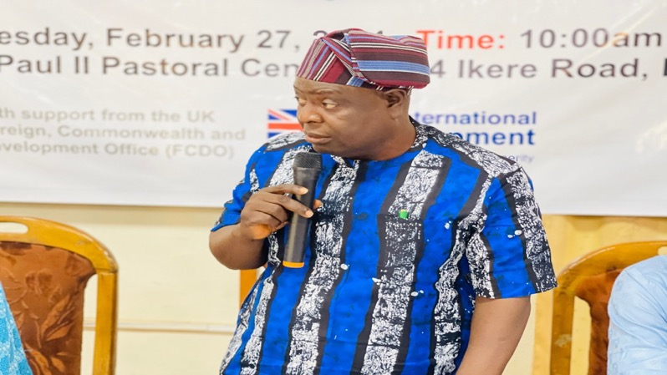

Chief Folorunsho Olabode, Commissioner, Ministry of Local Government Affairs is delivering his Remark

These Community Development Plans were presented to Ekiti State Agencies representatives who were present at the launch. Commissioner Olabode, while presenting the community development plans to the state agencies at the launch of the 3-Year Community Development Plans of 8 Local Governments in Ekiti State, urged them to maximize the opportunity and utilize the plans in their work.
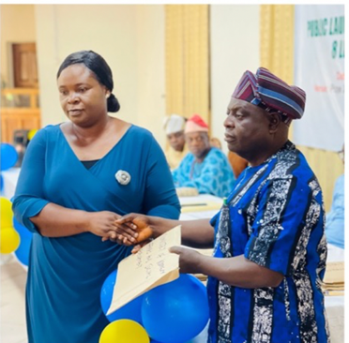
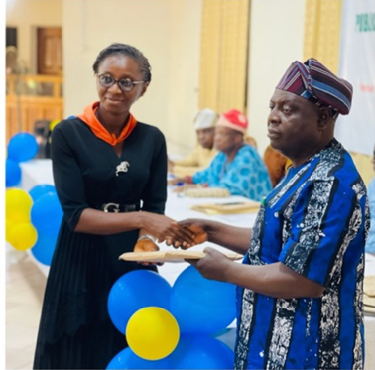
Commissioner Olabode, presenting the community development plans to the state agencies at the launch of the 3-Year Community Development Plans of 8 Local Governments in Ekiti State.

Remarks from the Stakeholders at the Public Launch
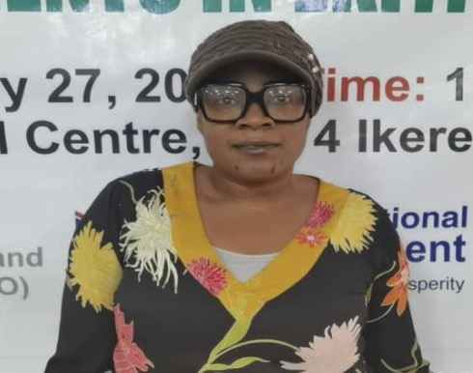
Ayodele Olubunmi Esther, one of the attendees who is a member of the Joint National Association of Persons with Disabilities, expressed her happiness over the inclusion of PWDs’ needs in the Community Development Plans and urged the government to implement these plans.
Ayodele Olubunmi Esther, Ayodele Olubunmi Esther, one of the attendees who is a member of the Joint National Association of Persons with Disabilities

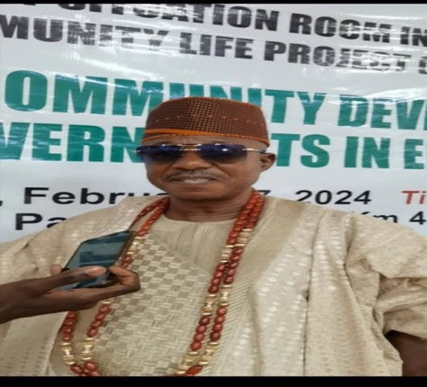
High Chief Ogunsakin Oluwole, the Chairman of Ekiti Traditional Chieftaincy Title Holders, Asolo of Ikole Ekiti, representing Elekole of Ikole, said the programme introduced by CLP is going to be a good development at the grassroots, especially in the LGs captured in the plans

High Chief Ogunsakin Oluwole, the Chairman of Ekiti Traditional Chieftaincy Title Holders, Asolo of Ikole Ekiti

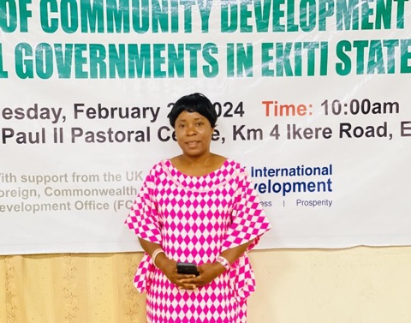

Mrs. Omolabake Adu, the Director of Budget, Planning, Research and Statistics for Ikole LG, expressed her happiness over the success of the plans in Ikole LG, which started in December 2023, stating that they went round all the 25 communities in Ikole to collate their needs assessment.
“We met with the stakeholders and the sensitization to let traditional rulers know we'll be coming to their community at a given date and time. The date given to us to do mobilization for the people. They responded well when the needs assessment ranged from good roads, electricity, and potable water. We want the government to use these plans as a yardstick for development in the state. They can look into these plans to make their budget every year so that they will see the needs of the people within the communities of Ekiti State. They should look into this and put it in their budget to assist the communities. It will benefit the community if the government can implement some of these projects,” she explained.
Mrs. Ado Omolabake, the director of budget, planning, research, and statistics for Ikole LG

Post – Launch
A day after the event, CLP paid a courtesy visit to Ministries, Departments and Agencies in Ekiti that were unable to attend the programmme to present the Community Development Plans to them.
Mrs. Yewande Adesuwa, the Project Coordinator of the Adolescent Girls’ Initiative for Learning and Empowerment (AGILE), receiving the 3-Year Community Development plans for 8 Local Governments in Ekiti State from the CLP team.

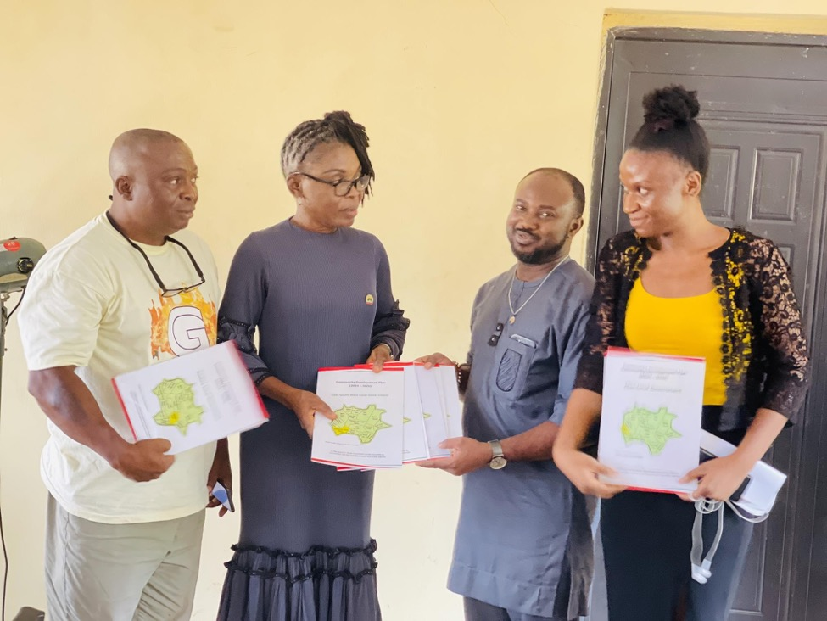
Mrs. Adeluyi Sola, the Permanent Secretary of the Ministry of Youth and Development, receiving the 3-Year Community Development plans for 8 Local Governments in Ekiti State from the CLP team.

